[DP-7] The words in the chart are being cut
Created: 26/Apr/24 Updated: 26/Apr/24
Status: | To Do
Project: | Dominos Pizza

Type: | Bug | Priority: | Medium
Reporter: | Tomer Darmon | Assignee: | Unassigned
Environment: | - One plus 11 5G Android version : 14  - Samsung Galaxy S10 Android version 12

Attachments: | 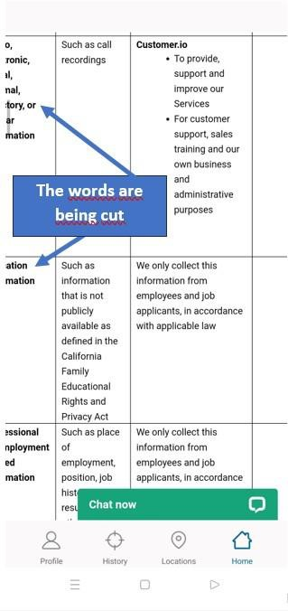
Severity: | S5 - Low

Description
Steps to Reproduce :
- Open the Domino's Pizza app
- Go to the top left corner and choose the menu
- Choose the option “Membership Terms”
- Scroll down until you reach the option “See Customer.io´s privacy statement” and click on it
- scroll down until you will reach to the chart
Actual Result : The subtitles in the chart is being cut
Expected Result : Expect that the chart titles will be readable and not cut or with missing letters

18

